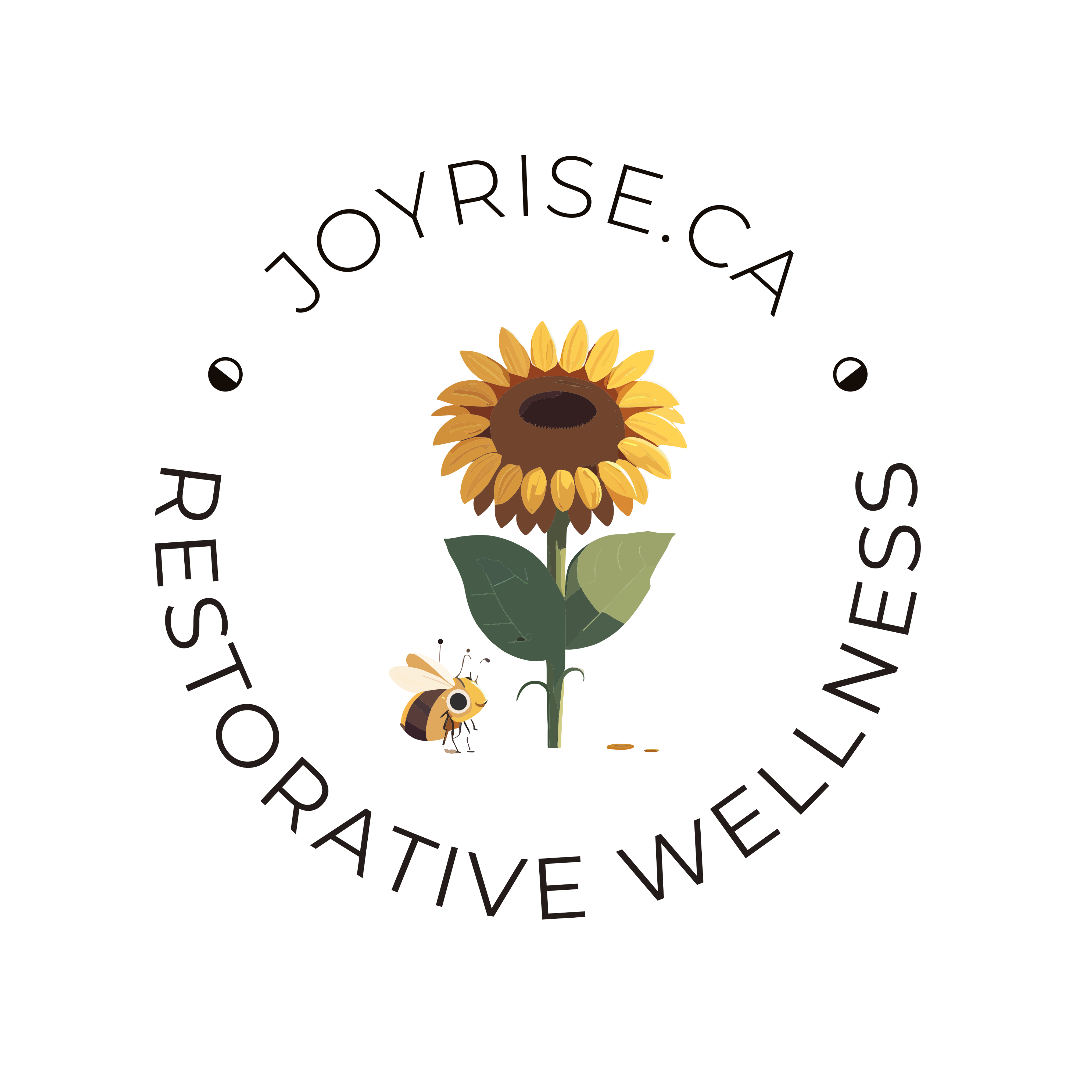

WELCOME TO JOYRISE.CA
200 HOUR YOGA TEACHER TRAINING!

This program has been created to share with you the practice of Yoga in the way that it has touched my world!

During this program, you will be introduced to the traditional eight limbs of Yoga as well as the Yogic lifestyle of spiritual practice, self care and creativity.

Yoga originally found me at the young age of 6 when I began spending most of my time with the Hindu family of my best friend. Growing up in a highly dysfunctional environment, I found solace in the stability and equanimity of my best friend’s household. Her family treated me with love and respect, and I always felt welcome. I remember sitting with her Father for hours around their large round table, listening to his stories, advice and Yogic wisdom. I spent the good part of ten years with their family in Etobicoke, Ontario before I left home at the age of 15 to explore the big city of Toronto. Almost three decades later and a lot of healing within my family, we are still best friends and her Father remained one of my greatest teachers until his death in 2025. He continues to be one of my Yogic guides from the other side.

In 2003, I officially entered my first Yoga Studio, Joy of Yoga. I remember all the thoughts running through my mind as I lay on my mat. A part of me wanted to walk out but the other part of me reminded me how important it was for me to stay. I remember the teacher reminding the class to breathe, and so I did. When the class was over and we lay in Savasana, I remember the tears streaming down my face. My body was releasing years of stuck energy and emotion, without me having to say a word. It felt good. It felt really good.

Since then, I have devoted my life to practicing and studying the healing arts and am multi-accredited in the areas of Yoga, Ayurveda, Aromatherapy, Energy Medicine, Trauma Awareness, Expressive Arts, Equine Guided Wellness and more. My cv is available for your review at www.JoyRise.ca. In 2024, I officially became a Certified Yoga Therapist with the International Association of Yoga Therapists.

In developing this program, I have compiled information from decades of training and personal life experience with Yoga. I am humbled and honoured to offer these teachings to you on our adventure together of your becoming a Certified Yoga Teacher, in the Art of Sadhana!

Guided by the wisdom of Nature, it is my hope that you will find this program to be one of transformation and enrichment, as you walk the path of coming home to who you truly are!

In the Spirit of Yoga,
Fotini Chandrika (CYT, E-RYT 500)

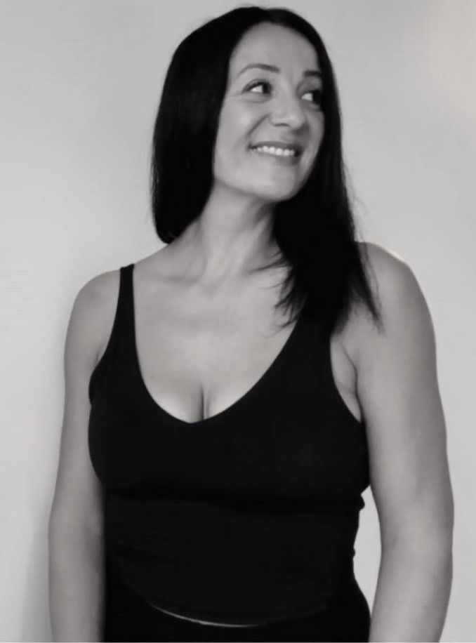

INDEX OF RESOURCE MANUAL

1. SANGHA - Four Agreements
Sangha Pledge

2. SAFETY - Yoga Safety and Contraindications

3. YOGA HISTORY- Read and contemplate “The Bhagavad Gita”
Read “Teaching Yoga” Chapters 1 & 2
Read “Yoga Sutras of Patanjali” page 117-167
Bhagavad Gita (Mahabharata), Rig Veda (Upanishads)
Yoga Sutras (eight limbs of yoga, yamas and niyamas)
Traditional Types of Yoga
Evolution of Yoga

4. EXPRESSIVE ARTS-Art as Medicine (low skill/high sensitivity)
Art as Yoga
Practicum – Circle Instillation & Studio Presentation

5. YOGA ANATOMY- Anatomy Coloring Exercises
Read “Teaching Yoga” Chapter 4
Read “Anatomy of Yoga” Chapter 1-4
Physical Anatomy
Yoga Psychology
The Wisdom of Emotions
Trauma Sensitive Yoga
Quiz

6. AYURVEDA (Intro)- Doshas & Assessment
Common Practices (diet & lifestyle)
Self Care and Spiritual Practice
Quiz

7. YOGA LANGUAGE- Reference “Teaching Yoga” Glossary Appendix B
Common Yoga Terms
Ayurvedic Terms

8. YOGA ASANA- Read “Teaching Yoga” Chapter 7
Reference “Anatomy of Yoga’ Chapter 5
Reference “Teaching Yoga” Appendix C
Contraindications (pregnancy, back care, wrists, knees, shoulder, neck, menstruation)
Forward Bends
Back Bends
Twists
Balancing
Inversions
Counterposes
Transition/Resting/Restorative
Quiz

9. SEQUENCING- Read “Teaching Yoga” Chapter 10
The Sequence of Practice
Sun Salutation
Yoga for Doshas
Quiz

10. PRANAYAMA- Read “Teaching Yoga” Chapter 3 and 8
The Subtle Bodies (chakra, gunas, nadi, vayu, kosha)
Strengthening Prana
Types of Pranayama
Balancing Chakras
Quiz

11. MEDITATION- Read “Teaching Yoga” Chapter 9
Contemplative Practice Tree
Introduction to Mediation for Children
Guided Meditations
Yoga Nidra
12. SACRED SPACE- Read “Teaching Yoga” Chapter 5
Creating a Home Altar
Creating Space for Transformation

13. SPECIALTY YOGA-Working with Children
Chair Yoga
Partner Yoga
Aroma Yoga
Reiki Restorative Yoga
Yoga with Animals

14. GOING DEEPER- Mantra
Mudra

15. TEACHING YOGA- Read “Teaching Yoga” Chapter 6
Verbal Cues
The Student/Teacher Relationship
Assisting/Adjusting/Using Props

16. BECOMING YOGA- Vision Journey – Sharing Your Gifts
Vision Board
Practicum (Teaching Yoga Classes)
(Feedback Forms to be completed by Teacher Trainee and “Student/Client)

17. MARKETING- Marketing Your Services
Networking
Biography and Photo
Social Media

18. “BUSINESS”- Business Models
Work Space
Insurance/Accounting
Karma Yoga/Selfless Service

19. FORMS- Yoga Class Waiver (general)

20. MOVING FORWARD-
Yoga Alliance (registration, continuing education)
Specialty Training (prenatal, children, RYT500)
Yoga Conference (continuing education)

Our program is designed for Yoga practitioners of any level as well as the ‘Yoga Curious’. You do not need extensive Yoga experience to receive the benefits of this experience. You do need an open mind, open heart, and a strong belief in something greater than yourself that is the Life Force of All That Is on our planet, often referred to as the Universe, Creator, God, Source, Divine, Nature, Gaia….

THIS IS OUR 2025 IN-PERSON TRAINING SCHEDULE:
TRAINING COMMENCEMENT: September 27, 2025

3-day intensive trainings will be held in our Colgan studio from 10am-5pm each day, once per month. Students will be required to attend a minimum of one yoga class per week with Fotini during the duration of their training. Attendance at any one-hour Yoga classes offered at JoyRise.ca Studio is included in the Yoga Teacher Training Tuition. Students are encouraged to attend class half an hour early and stay half an hour after class to engage in class preparation and debriefing.

Students will experience two Yoga-Related field trips as a group as well as a full day graduation retreat.

LIVE WEEKEND TRAININGS:
Sept 27, 28, 29 2025
Oct 25, 26, 27 2025
Nov 22, 23, 24 2025
Dec 13, 14, 15 2025
Jan 24 2026 (graduation)

You will be required to bring a packed lunch for the on-site trainings, which will be from 10am-5pm each day.

Lunch will be included in the Graduation Retreat

There will be assigned readings, quizzes and assignments throughout the duration of the training. Tuition does not include specialized trainings or unrelated retreats.

YOGA TEACHER TRAINING PROGRAM
2025 PAYMENT SCHEDULE
$4,444 plus hst = $5,021.72

Non Refundable Deposit: $500 Due upon registration

Payment 1 Amount $1,507.24 Due Sept 15
Payment 2 Amount $1,507.24 Due Oct 15
Payment 3 Amount $1,507.24 Due Nov 15

Tuition Fees are non refundable and non transferrable.

Thank you for inquiring about our upcoming Yoga Teacher Training Program!

We hope you will join us and live Yoga on and off the mat!

In service,

Fotini Chandrika, CYT, E-RYT 500
JoyRise.ca

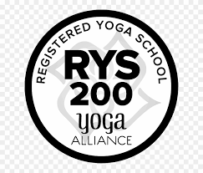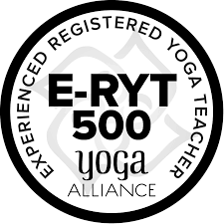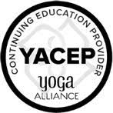

We are located at 2176 Adjala Tecumseth Townline, Colgan, Ontario, Canada, L0G1W0.

Please let us know if you have any further questions or proceed to fill out the Application below if you are ready to take the next step!

YOGA TEACHER TRAINING APPLICATION

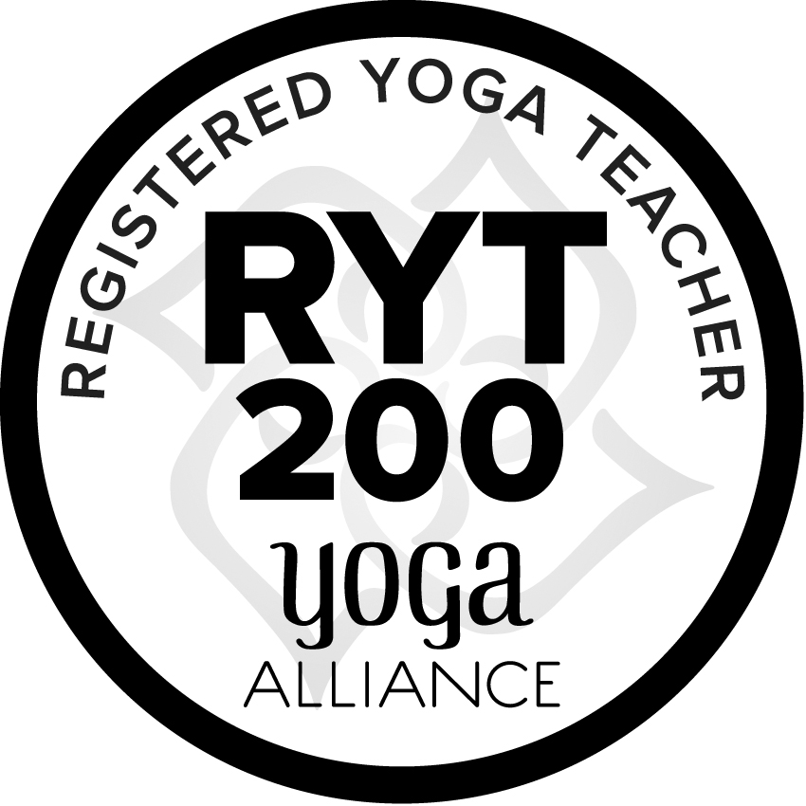

Full Name:

Mailing Address:

Telephone:

Email:

Date of Birth:

Please describe your previous yoga/meditation experience:

Please briefly tell us about your professional work history and training programs:

Please share why you are applying to become a Certified Yoga Teacher:

Do you have any health/medical concerns that may impact your ability to learn Yoga Asana (postures) and engage in spiritual practice (sadhana)? Please also inform of any allergies (food, environmental and otherwise).

Signed: _______________________________ Date: _________________

*I hereby acknowledge that this program may be subject to changes without notice

